Website Data

**OUR EXPERTISE**

1. LEADERSHIP DEVELOPMENT

Every organization is unique, and its leaders should be too. We proudly present Stewart Leadership Development Models in the Middle East. For over 40 years, Stewart Leadership has been developing leaders, building high-performance teams, and supporting organizations to achieve strategic results for Fortune 500 and mid-sized companies, government agencies, and start-ups.  Our Executive Leadership Workshops provide a customized training experience to help your upper management team hone skills in interviewing, assessments, action planning, and more. Your employees will gain the tools needed to lead in a way that best represents your company’s values and mission.

Next page: LEAD NOW Model

1. EXECUTIVE COACHING

Executive Coaching builds and sustains leadership and capability through focusing on the leader’s needs and desired outcomes necessary to achieve organizational goals. Coaching assesses and identifies a leader’s strengths and gaps and is followed by the creation of a customized individual action plan with built in success measures and accountability connecting to on-the-job learning experiences while aligning with organizational strategies. Executive Coaching takes place one-on-one, although programs can be designed for group or team coaching situations as well.

Next page: Attached document

1. MIDDLE MANAGEMENT DEVELOPMENT

We customize learning programs to develop the skills of organizations’ current and potential managers through focusing on the four key management functions: Planning, Organizing, Leading and Control.

Next page: Below

1. STAFF DEVELOPMENT

Our unique competency based models address key skills required for staff development.

Next page: Models below

1. TEAM BUILDING EVENTS

Of all the challenges faced by organizations today, team-building ranks as one of the biggest and most critical. With organizations increasingly dependent on high-performance teams for virtually every activity, teamwork has become a major business strategy—and getting teams to work an absolute necessity. We customize special events to focus on different team challenges faced by organizations and objectives to be achieved.

Next page: photos and video

1. ASSESSMENT CENTERS

Assessment centers and Development centers are the most effective and valuable tools that enable organizations to evaluate and select best calibers to position them in the right jobs. We help our clients to achieve that through our international assessment partners and highly competent assessors' network to provide you with unique assessment and development centers experience that will impact your talents' selection and development decisions.

Next page:

1. CONSULTING SERVICES

Through our network of international consultants, we assist organizations in the following services:

Building Organizational Culture

Implementing Change

Talent Acquisition and Executive Search

Competencies Framework Design

Instructional Design of Learning Programs

**LEAD NOW Program** (check SL page, add same info and video, or add a link to this page as agreed)

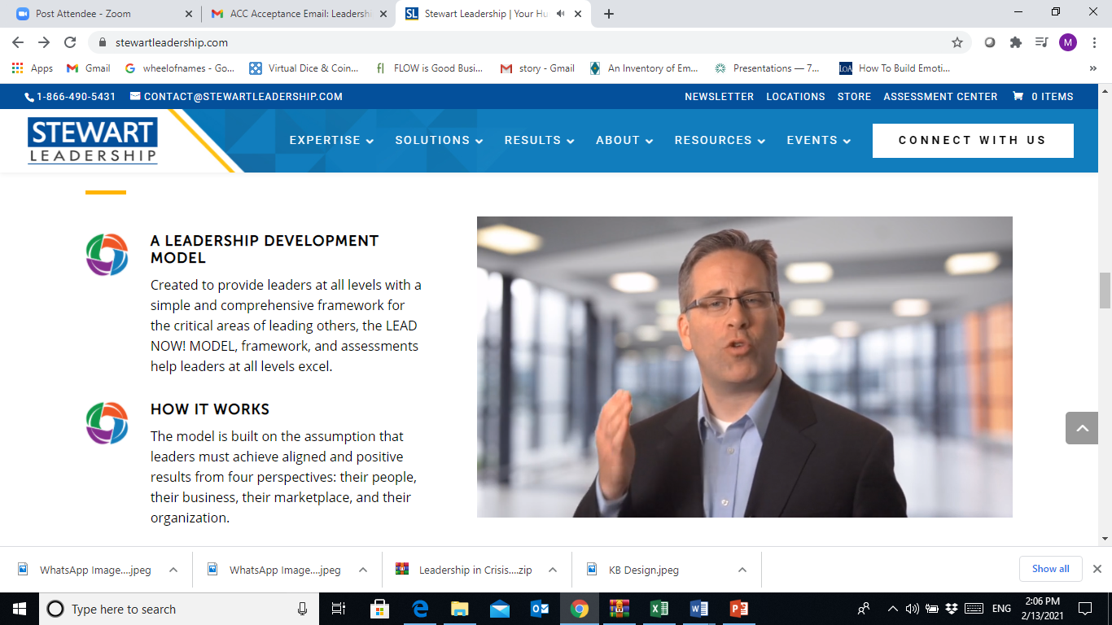

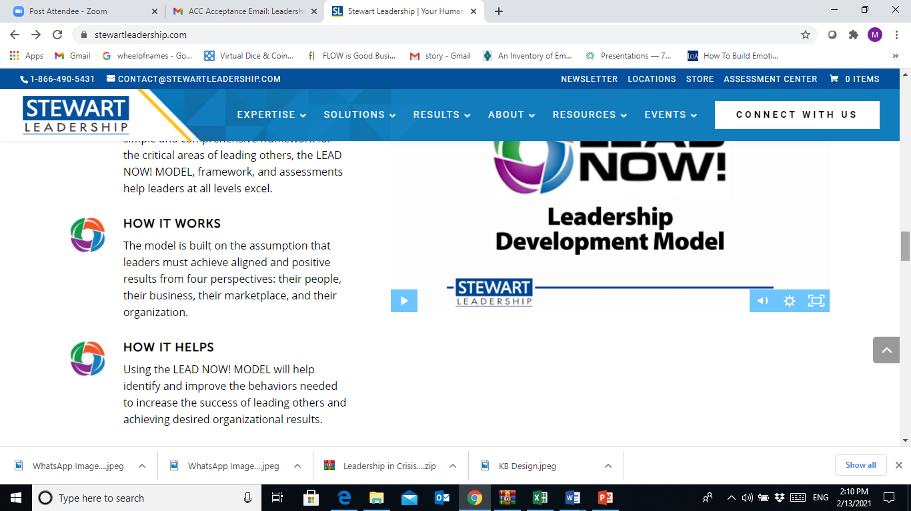

**MIDDLE MANAGEMENT PROGRAM**

In order to acquire the skills needed to join the executive leadership team, middle managers must [strengthen their core manager functions](https://blog.stewartleadership.com/strengthening-your-management-core). Without a strong foundation, it’s difficult for mid-level managers to achieve high performance and promotion. That’s why Leading 365 management development program revolves around these **five key functions**:



**PLANNING**

Establishing a clear understanding of the organization’s business, goals, strategies, and vision allows managers to set clear goals and expectations for their team. Managers will learn to communicate clearly what is and isn’t important by considering timing, possible roadblocks, and desired results. This helps to create purpose, which enhances engagement and improves productivity. It all starts with planning.



**ORGANIZING**

As a middle manager, it’s crucial to know how to select the right people to own and deliver the results of a particular assignment. Our manager development program hones in on mastering the art of delegation. Managers must be able to deliver the what, when, and why but not the how. This allows employees to discover the how on their own, which ultimately helps the development of both the leader and the employee. Prioritizing workload, managing conflict, and effectively delegating are all components of delivering excellence.



**TEAMING**

Evolve the skills needed to select, develop, retain, and motivate a team. Managers will learn to identify their team’s current state and determine specific actions needed to shift them from chaos to stability, and then into high performance.



**EMPOWERING**

Managers will learn to engage others in such a way that they feel empowered and have a willingness to try something new. It takes time and trust to inspire commitment and transform employees from being engaged to being empowered. Guiding employees to make and lead change can be difficult, but powerful.



**FOLLOW THROUGH**

To succeed as a mid-level manager, it’s more than just knowing what to do, why it needs to be done, when it’s due, and how to do it. Learning to focus on and achieve the end goal by holding self and others accountable is the path to delivering excellence.

**STAFF DEVELOPMENT**

Our game-based unique models are created to help staff practice the key skills needed for their personal effectiveness through our learning journeys. The models can be delivered as short bite-size sessions or longer programs based on client’s objectives.

All the models can be delivered virtual and face-to-face. (needs to be highlighted)

Add a design for the 5 models:

GROWTH Model

iLEARN Model

I CAN model

AAA Model

Be POSITIVE Model

GROWTH MODEL

Adopting a growth mindset is helpful to overcome difficult times. In this course, participants are introduced to the six skills that they need to be able to enhance their personal and professional growth especially during tough times:

* + - Gratitude
    - Resilience
    - Optimism
    - Wellbeing
    - Thriving
    - Happiness

Participants go through the six-phase journey that introduces the model and they practice each skill through interactive activities.

BE POSITIVE

Positive thinking is a mental attitude that expects positive results. A person with positive thinking anticipates success and believes that he or she can overcome obstacles and difficulties.

In this course, participants go through a journey to learn how to be a positive thinker. The journey includes 8 steps that help them to:

* + - Prioritize
    - Overcome negative thoughts
    - Seek a growth mindset
    - Initiate action
    - Track their progress
    - Influence others
    - Excel

AAA Model

Change is a constant in our lives. The current business world is characterized by dynamic and quick changes that require staff with high levels of Agility and Adaptability.

In this session, participants learn:

* + - to define Agility
    - to assess their adaptability skills
    - to identify types of change
    - the emotional reactions to change
    - the 7 traits needed for Agility and Adaptability
    - how to develop their Agility and Adaptability skills through practical exercises

ASSESSMENT CENTERS

**Do you have the right talent to meet your organizational objectives and goals today and tomorrow?**

“Top performing organizations were found to be using assessments more broadly across employee populations and job roles, as well as more frequently and consistently than other organizations.”

*-Talent Assessment Strategies: A Decision Guide for Organizational Performance by “Aberdeen Group”*

Organizations using assessments are:

* + **24% more** likely to have a ready and willing successor named for each key position

And demonstrated a:

* + **75% greater year-over-year** improvement in hiring manager satisfaction
  + **75% year-over-year decrease** in hiring costs
  + **2.5 times greater year over year** increase in profit

Our psychometric assessment tools and behavioral assessments can be used for:

* Hiring and Selection
* Workforce/Succession Planning
* Organization Restructuring
* Performance Management
* Training Needs Assessment